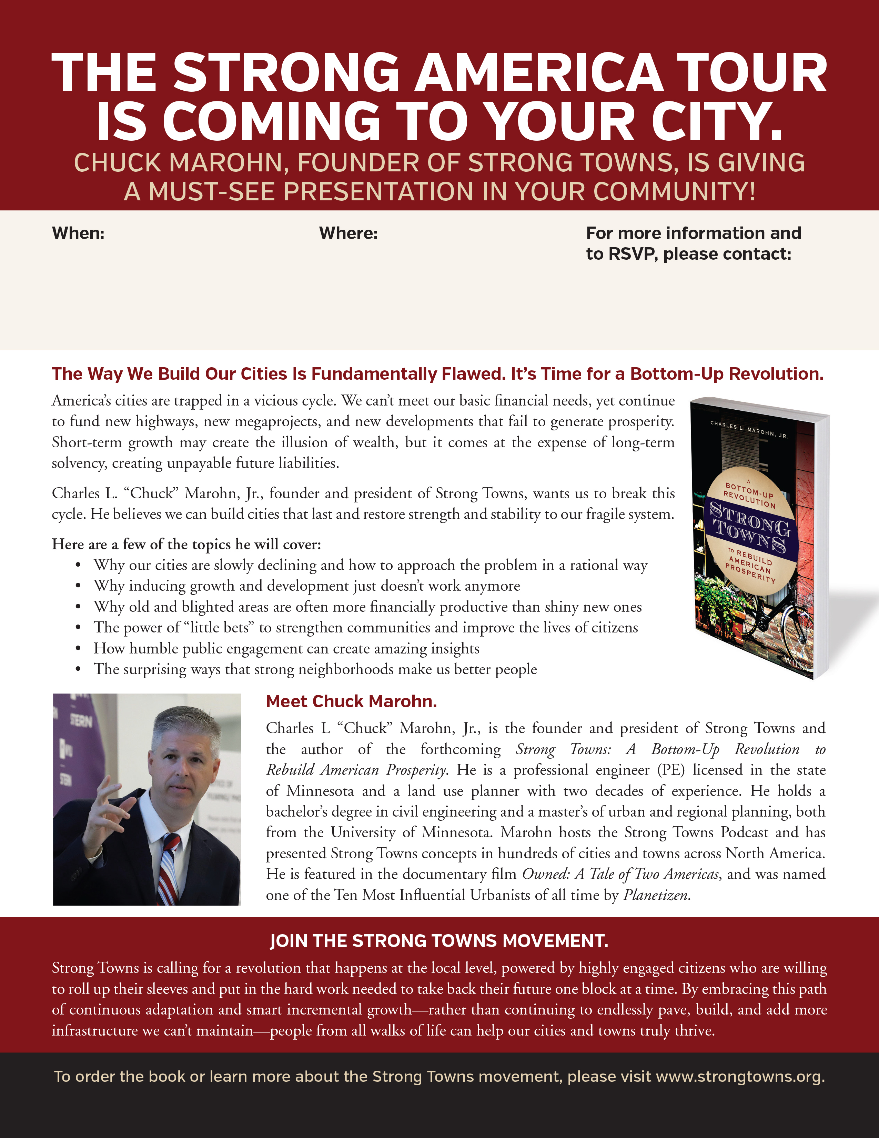

Lillie Read

[lread@downtowncartersville.org](mailto:lread@downtowncartersville.org)

https://strongtowns.eventbrite.com

The Grand Theatre

7 N Wall St

Cartersville, GA 30120

Friday, October 4th

12:00 p.m